COLEMAN UNIVERSITY Computer Information Systems Name: Michael Fetick
COM 280 Object Oriented Analysis and Design Student No. 84270
NOTE: The Syllabus, the Course Schedule and the Student Manual were provided only on a hard-copy media. After these class notes were typed, I have not transferred my written notes to text yet.
Activity Diagram
My Notes
Activity diagram: who, how, workflow. Swim lanes (for actors), start, transition, activity (elongated round box), states (rounded square).
Exercises – Activity Diagrams
COLEMAN UNIVERSITY Computer Information Systems Name: Michael Fetick
COM 280 Object Oriented Analysis and Design Student No. 84270
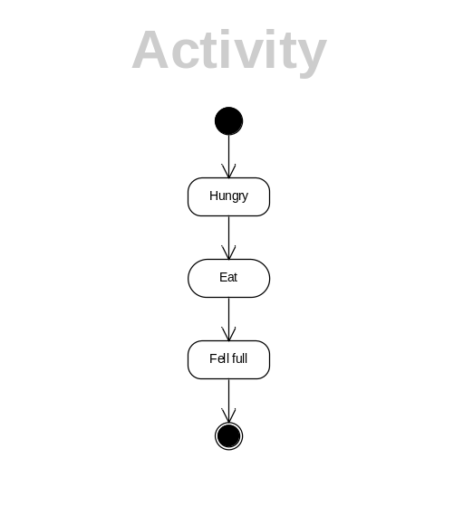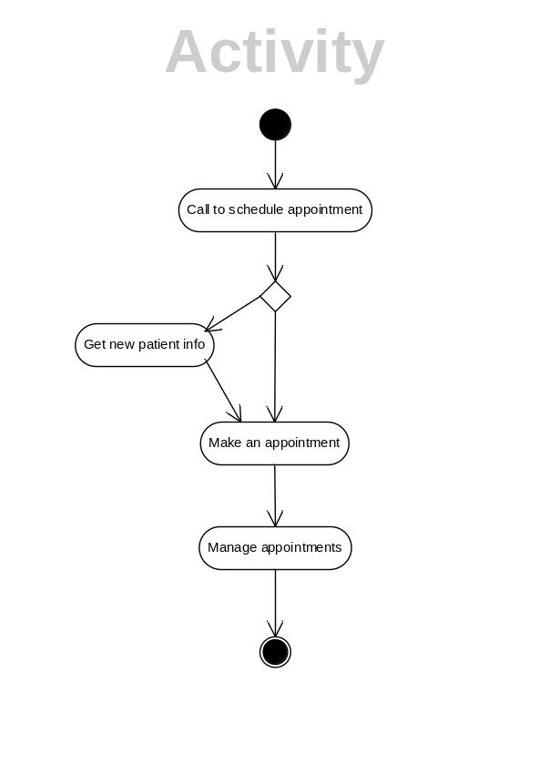
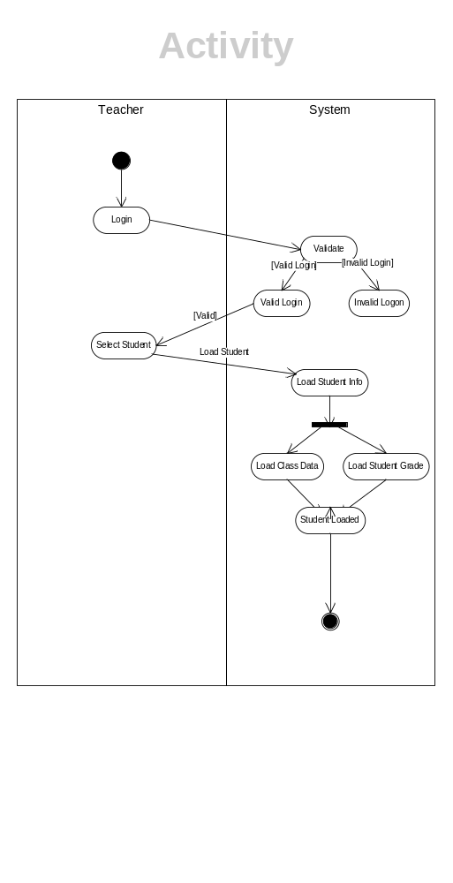
Project 2 – Activity Diagram
Project 2
Activity Diagram
- Develop an activity diagram for Figure 6-10
- Develop an activity diagram for Figure 6-11.
- Include the following components in your activity diagrams:
- Activities
- States
- Transitions
- Guards and decision points
- Events and triggers
- Swim lanes
- Forks and joins
Due date: Tuesday, June 18, 2013 11:30 p.m. PDT.
Name of file: COM280 Project 1 Firstname Lastname
Email project to ckoon@coleman.edu
Details
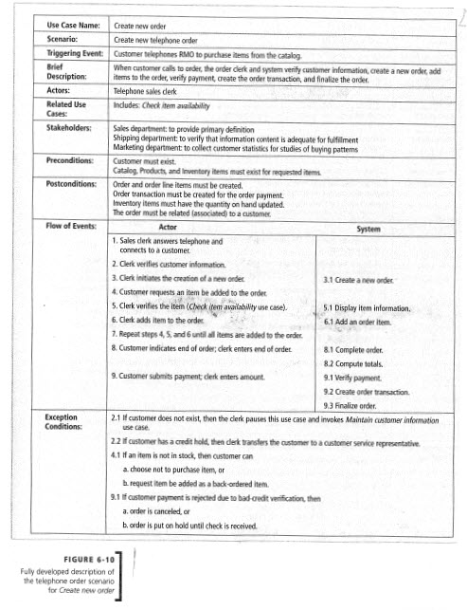

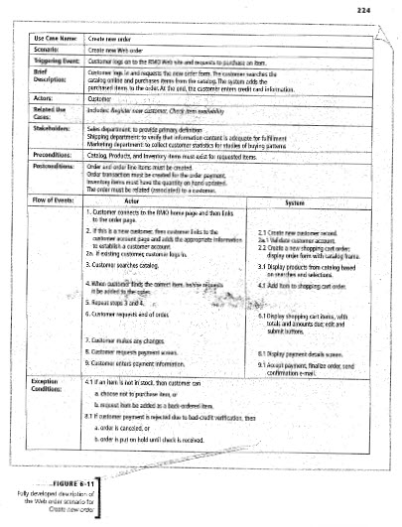

COLEMAN UNIVERSITY Computer Information Systems Name: Michael Fetick
COM280 Project 2 (5 points) Student No. 84270
